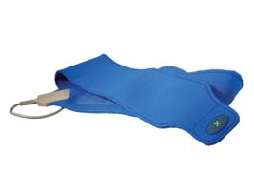 | Item Code: HTE-SE019  E-Power Belt  USD $ 109.00  BVP 5

Replacement or the second E Power belt for your E POWER machine.

Keep Dry, Do Not wet, Do Not Wash Belt.
Do not unplug unless the machine is off or unless the machine is on PAUSE.

