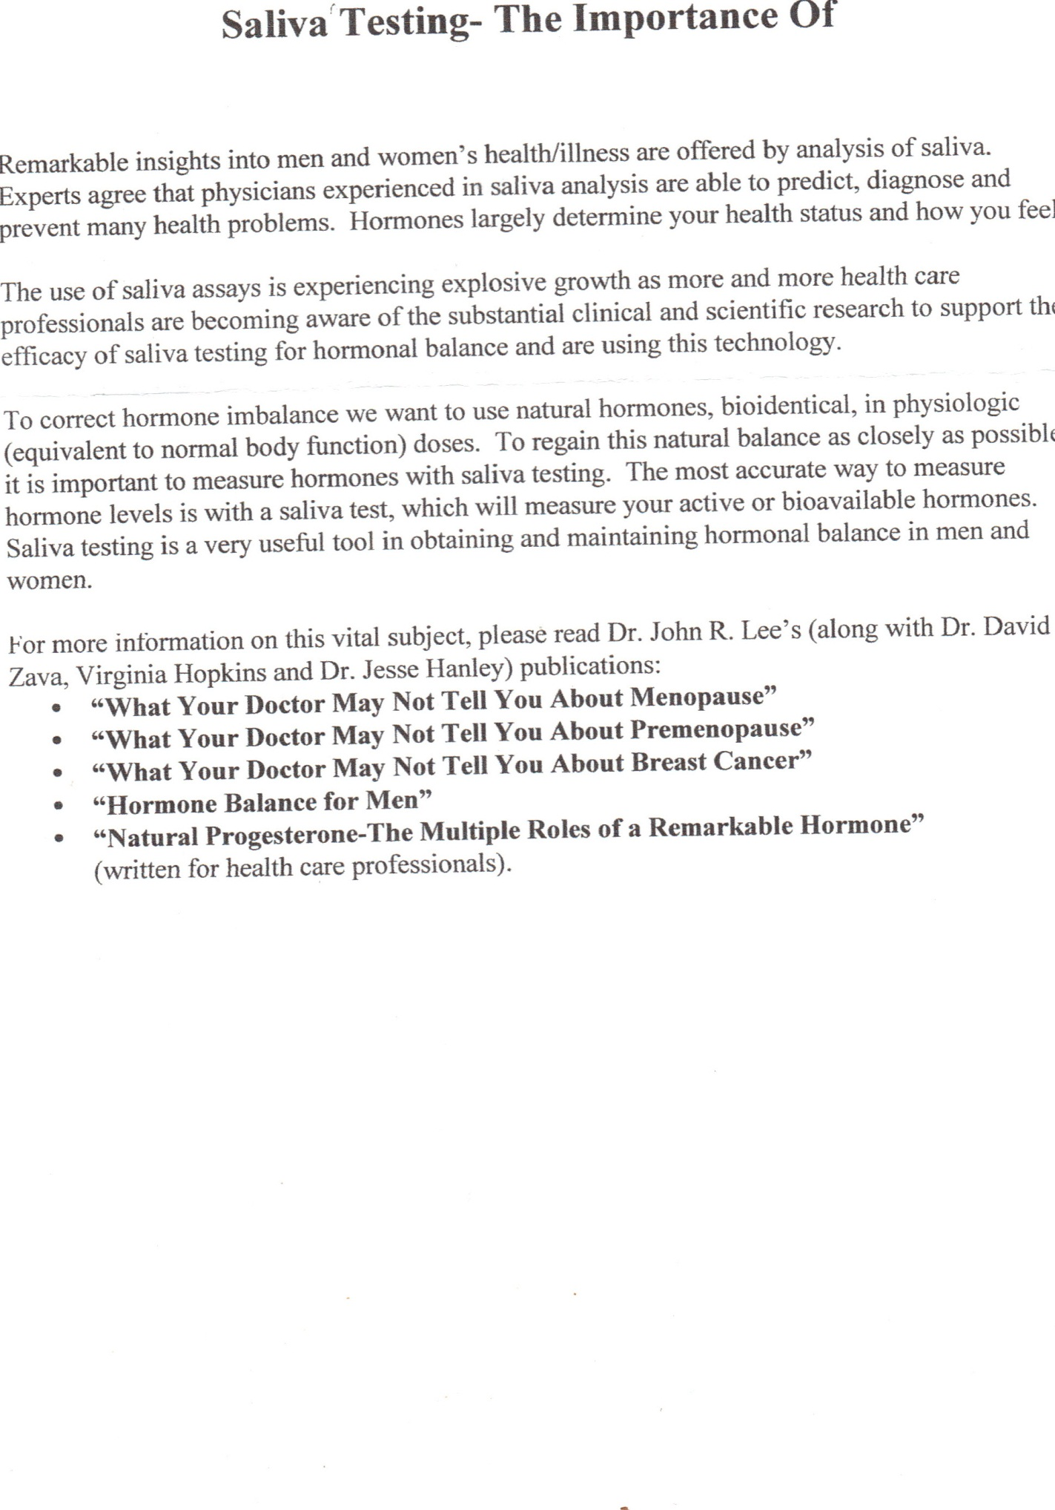
Saliva test: measure what is going on inside the cell. In the case of hormones that is where they are needed.
Blood test: measure the area outside the cells.
Urine tests: measure the overflow which blood and cells can’t hold or get in.
