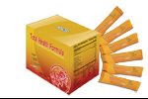 | Item Code: HTE-NS007  Total Health Formula  USD $ 49.00  BVP 4

