Qualities & Advantages
1) Perfect Combination of Eastern Traditional Medicine and Western Health Technology: The SOQI Total Health Management System consists of traditional Chi Kong, Chiropractic, Massage Therapy, Physical Therapy, and Spa, all of which are fully natural. Along with our scientifically engineered technology and health-care equipment, we are able to offer a system of multi-energy “Total Health Management”.
2) The SOQI Home Spa is a modern day health enhancing management system: Energy, oxygen, light therapy, and vegetable enzymes are the essential elements needed to achieve great health. The SOQI Total Health Management system combines Far Infrared Heat (Hot House), physical resonance (Chi Machine), low frequency waves (Advanced ERE), and supplemental enzyme’s, vitamins and minerals (Total Health Formula) to provide your body with a healthy synergetic balance. The SOQI Home Spa Management System delivers health, wellness and a strong sense of vitality.
3) Customized Health Management Monitoring System: On the surface of the skin, we can locate specific acupuncture points to examine one's health condition. We are able to measure the exact electrical resistance for each acupoint using the Energy Measurement Device (EMD); such data can be very useful toward the examination. With our expertise in Eastern and Western theories, we offer a suitable, healthy formula designed just for you, so you can continuously manage your health.
4) A True Experience with Exotic Luxury
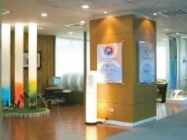
The SOQI Total Health Management System provides a feeling of deep relaxation, which can lead to a better night time sleep, improved joint mobility, and more energy for its users. As our body adapts to the SOQI Home Spa environment, it begins to thrive in a nourishing, healthful and wholesome environment. The SOQI experience is magical and can best be described as the rejuvenation, revitalization and cleansing of the mind, body and soul.
5) A World-Class High-Tech Manufacturer:
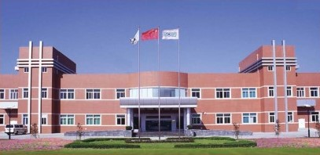
HTE has invested a great deal in the He Fei High-Tech District of China. In July of 2002, the thirteen thousand square foot Merit Technology Development was founded. During the same year, this facility earned ISO9001 recognition. In addition to receiving approval from the Chinese government’s pharmaceutical industry, we were also approved to provide our products in close to thirty other countries. Our products are very popular in these countries as our product development, operations management, and innovation of technology consistently continue to lead the industry.
6) Future Trends-The Chi Culture of Health Management:
Scientists have already proven the existence of Chi, and Chi is known for its amazing, natural, and effective anti-aging treatment. As increased numbers of people study Eastern Chi, we predict the future trend will continue to lean toward an all-natural Chi experience. We will not be surprised to see HTE dominate the industry over the next 10 years.

