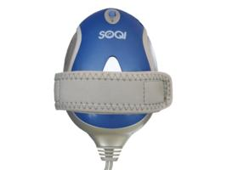 | Item Code: HTE-SP001  Palm Massager  USD $ 29.99  BVP 2

This palm massager is great. It provide a DEEP massage and PENATRATING HEAT at the same time.
Or use without heat. In addition, the speed and intensity of the massage is adjustable.
Sport medicine type massage. Once you experience this you won’t go back to the department store massagers.

This is not medical advice & shouldn’t be taken as such. Joni Lund
This machine may or may not do so, not evaluated by the FDA for such.

