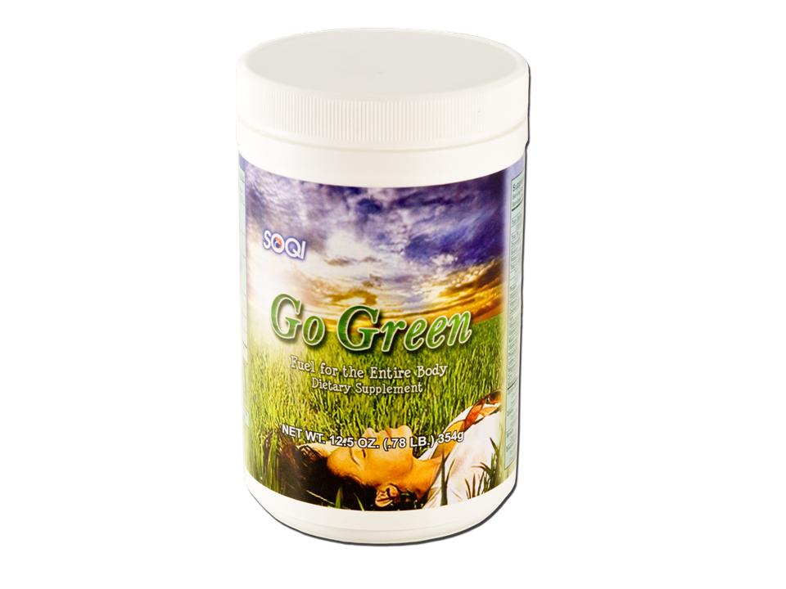 | Item Code: HTE-NQ011  New! Go-Green Supplement  USD $ 42.95  BVP 2

