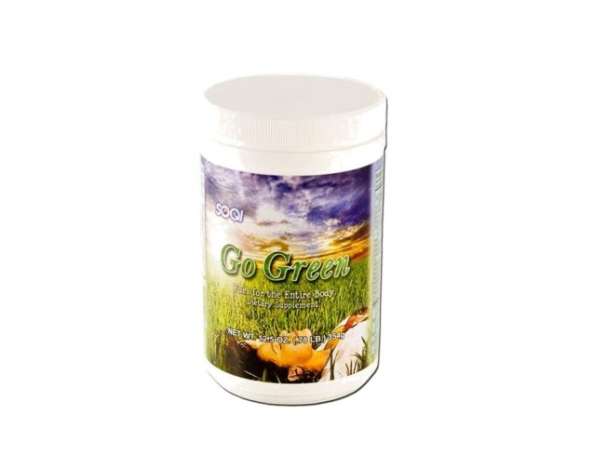  Some of the | Item Code: HTE-P0011L03  Go Green Supplement - 12 pack- (Enroll to Auto Ship and Get Free Shipping)  Package Content  - GO-GREEN SUPPLEMENT x 12  USD $ 383.40  BVP 20

The
3. Get Full of
Some of the benefits of this amazing product are:
1. Improve your nutrient absorption
2. Balance Your pH
3. Get Full of Energy

Go Green - Nutritional Supplement
Go Green is designed to energize, revitalize, alkalinize, cleanse, facilitate mental energy, support a healthy immune system and much more!
Go Green consists of a well-balanced blend of 77+ quality ingredients for your daily diet. Balance your pH and balance your body with Go Green!

