GO GREEN

"Fuel for the Entire Body"

Balance Your Body with GO GREEN!
Go Green is the ultimate pH balancer! What is pH? The pH scale is used to measure how acidic or alkaline the blood is. Just changing the pH by 1 or 2 points affects the body’s electrical chemistry drastically.
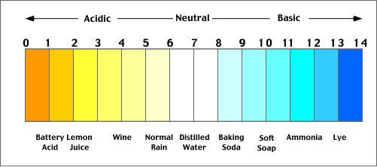
Your GOAL is to keep your pH in a balanced range of 6.8-7.2
When the balance is disrupted, death or illness can result.
An Imbalanced pH Can Lead to…
EARLY ACIDOSIS
- Acne
- Low sex drive
- Food allergies
- Bloating
- Difficulty waking up in the morning

MODERATE ACIDOSIS
- Asthma
- Urinary infections
- Excessive hair loss
- Depression
- Migraines
SEVERE ACIDOSIS
- Cancer
- Lupus
- Multiple Sclerosis
- Rheumatoid Arthritis
- Tuberculosis
What can cause an imbalanced / unhealthy pH?
- Dehydration
- Stress
- Food Additives
- Low quality food – refinded or factory processed.
- Exposure to toxic chemicals
- Too Much Caffeine
GO GREEN Q & A
Q: What is the pH scale used for?
A: The pH scale is used to measure how acidic or alkaline the blood is. Just by changing the pH by 1-2 points can affect the body’s electrical chemistry drastically.
Q: What are some of the signs and symptoms of an unhealthy pH?
A: Acne, Low sex drive, Food allergies, Bloating, Asthma, Urinary infections, Excessive hair loss, Depression, Migraines, Cancer, Lupus, Multiple Sclerosis, Rheumatoid Arthritis, Tuberculosis
Q: What can cause an unhealthy pH?
A: Dehydration, Stress, Chemicals, White Flour, Sugar, Alcohol, Meats, Any Refined, Processed, Enriched, or Preserved Foods
Q: I understand that Go Green balances your pH.. but what does it specifically do?
A: Go Green is designed to energize, revitalize, alkalinize, cleanse, facilitate mental energy, support a healthy immune system and much more.
Q: What is in Go Green?
A: Go Green consists of a well balanced blend of 77 quality ingredients for your daily diet. Ingredients include organic vegetables, leafy greens, grasses, sprouts and mushrooms. Plant-based enzymes, antioxidants, blend of herbs including Chinese traditional, friendly probiotics and sea trace minerals.
Q: How is Go Green harvested?
A: Go Green is grown in mineral-rich soils and harvested at peak nutrient levels for maximum phytonutrient value. Low temperature processing is used to maintain nutrient value, plus live enzyme and probiotic action.
Q: Can I trust the Go Green manufacturer?
A: You can be confident in this product. Go Green was designed by a medical doctor who is also a Homeopathic, Acupuncturist & Herbalist. The manufacturer is a Certified Organic Handler and Processor (USDA) and Kosher Certified laboratory located in the United States. They have been producing products for over 20 years!
Q: Is Go Green made with any preservatives or additives?
A: Go Green is not made with any preservatives or additives. In fact, Go Green consists of no wheat, dairy, chemicals, or artificial colors!
Q: What exactly is in Go Green?
A: The ingredients say it all. Inside one powerful scoop of Go Green you will find over 46 apples, 28 bananas, over 7.5 cups of blackberries, 19 asparagus spears, 4 tomatoes, 1.5 beets and over 28 ears of corn!
Q: What is the "muscle test"?
A: The muscle test is a before and after balance test that displays the power behind Go Green. The participant is easily thrown off balance before using the product. After taking Go Green, the muscle test proves that balance is more than restored.
Q: Can Go Green be used for weight loss?
A: Go Green can be used to supplement a meal. Take one to two scoops daily. For fastest results, use HTE machines with Go Green.

Restore your body, balance your pH and gain an unfair advantage with GO GREEN!
FACT:
A healthy immune system is the #1 key system to preventing sickness, viruses, bacteria, parasites, fungus & chemicals from damaging the body.
Go Green is designed to energize, revitalize, alkalinize, cleanse, facilitate mental energy, support a healthy immune system and much more…
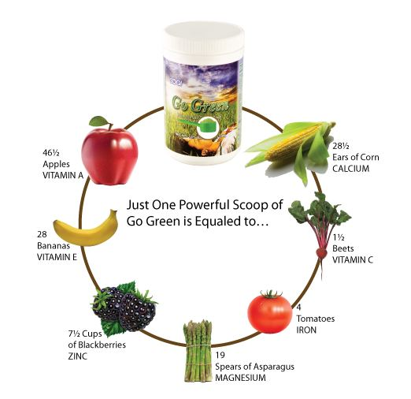

Go Green consists of a well-balanced blend of 90+ quality ingredients for your daily diet to include…
- Organic garden & leafy greens, vegetables, grasses, sprouts and mushrooms
- Plant-based enzymes
- Antioxidants
- Blend of beneficial herbs (including Chinese Traditional)
- Friendly Probiotics
- Sea trace minerals
Go Green is…
- Grown in mineral-rich soils
- Harvested at peak nutrient levels for maximum phytonutrient value
- Low temperature processing maintains nutrient value, plus live enzyme and probiotic action
- High nutrient density – ingest less for optimum nutrient level
Go Green has…
- NO additives
- NO artificial colors
- NO preservatives
- NO chemicals
Go Green helps…
- prevent chronic acidosis.
- feed the body alkalizing nutritional supplements and stay Ph balanced.
- develop a positive mindset and sustain a healthy lifestyle.

Main Supplement Facts
Garden Blend (Organic Juice Blend)
(Carrot Root, Kale Leaf, Fennel Root, Spinach Leaf, Collard Greens, Parsley Leaf, Swiss Chard Leaf, Beet Root, Broccoli Tops, Cabbage Leaf), Zucchini, Fermented Green
Greens
Organic Barley Grass Juice, Spirulina, Organic Alfalfa Juice, Chlorella, Klamath Blue Green Algae
Sprouts
Organic Buckwheat Sprouts, Organic Quinoa Sprouts, Organic Rye Sprouts
Essential Fat and Herbs
Soy Lecithin, Hawthorne Berry Extract, Hawthorne Flower, Gingko Biloba Extract (24/6), Ginkgo Biloba Leaf
Enzymes
Plant-based Protease, Amylase, Lipase, Hemicellulase, Lactase, Green Papaya Fruit, Papain (50,000 FCC/Gram), Bromelain (2,000 GDU/Gram)
Herbs
Nettle Leaf, Celandine Herb, Angelica Root, Chinese Peony Root, Jujube Fruit Extract, Milk Thistle Seed Extract, Milk Thistle Seed, Dandelion Root, Dong Quai Root Extract, Dong Quai Root, Yucca Plant
Antioxidants
Green Tea Extract, Rose Hips Extract, Rose Hips, Grape Seed Extract, Acerola Berry Extract, Bilberry Fruit Extract, Bilberry Leaf, Royal Jelly
Chinese Traditional
Eleuthero Root, Schizandra Berry Extract, Astragalus Root, Bai-Zhu Atractylodes Rhizome, Astragalus Root Extract, Bai-Zhu Atractylodes Root Extract, Eleuthero Root Extract, Licorice Root Extract, Fo-Ti Rhizome Extract, Ginger, Fo-Ti Rhizome, Ginger Root Extract, Bupleurum Root Extract, Bupleurum Root
Mushrooms
Poria, Organic Cordyceps Mycellia, Organic Maitake Mycellia, Organic Reishi Mycellia, Organic Shitake Mycellia
Probiotics
L. Acidophilus, S. Thermophilus, B. Bifidus, L. Bulgaricus, Lactospore
Sea Trace Minerals
Irish Moss, Red Dulse
Other Ingredients: Enzymatically Hydrolyzed Rice, Stabilized Rice Barn, Apple Fiber, Sunflower Seed Oil, Guar Gum, Apple Pectin, Natural Plant Flavors, Tevia Leaf Extract.
Suggested Daily Use: Mix 1 scoop into 8 to 12 oz. of water or favorite beverage and mix vigorously.
Best to drink immediately. Store at room temperature.
For infants and children less than 4 years of age or if you are pregnant, lactating, taking medication or have a medical condition, consult your healthcare professional before using this product.
THESE STATEMENTS HAVE NOT BEEN EVALUATED BY THE FOOD AND DRUG ADMINISTRATION. THIS PRODUCT IS NOT INTENDED TO DIAGNOSE, TREAT, CURE OR PREVENT ANY DISEASE.

TESTIMNIALS:
To Whom It May Concern:
I am writing in reference to the Go Green product and the amazing results we had with my son.
My poor kid has suffered with severe eczema all his life and he is now 17. When he reached puberty he was then plagued with severe acne also. He pleaded with me to take him to a dermatologist but I have been adamant about him using anything that may have cancer causing effects even in high dosages with rats. So, we tried every natural cure and diet we could find to known available.
His eczema was so bad on his arms that the skin was raised, bright red, bleeding and almost ropey looking like a burn. He was wearing bandages at night so he wouldn’t scratch and make it worse. His face was completely covered in zits. There was no space where you could even see regular skin. He was desperate and so was I. He was so embarrassed to go to school and one morning the eczema was so bad that we had to bandage his arms to hide and protect. He was using make-up on his face because he was so sensitive about how he looked.
The day after the bandaging episode I went to my therapist, Tom Benson, and mentioned that I was looking for a “green” product for my girlfriend who wanted to detoxify because of some lymphoma issues. Tom recommended the “Go Green” and did the muscle test on me. Of course, I fell over and decided to take it home. I talked my kid into trying it and low and behold, the NEXT DAY, the eczema disappeared. It was unbelievable! About 90% of it was gone and the ropey, thick skin was flat and all that was left were a few scabs. The bright redness also disappeared. His face literally cleared up also. I’m not saying there were no zits but amazingly his face almost looked clear and was nice and smooth.
We didn’t take "before" pictures because we had no way of knowing we would have these stupendous results!
I would highly recommend this product to anyone suffering from eczema and I can tell you from experience that we have tried everything since he was a baby.
I thank the man that developed this product; you saved my kid’s skin and his mental well-being!

