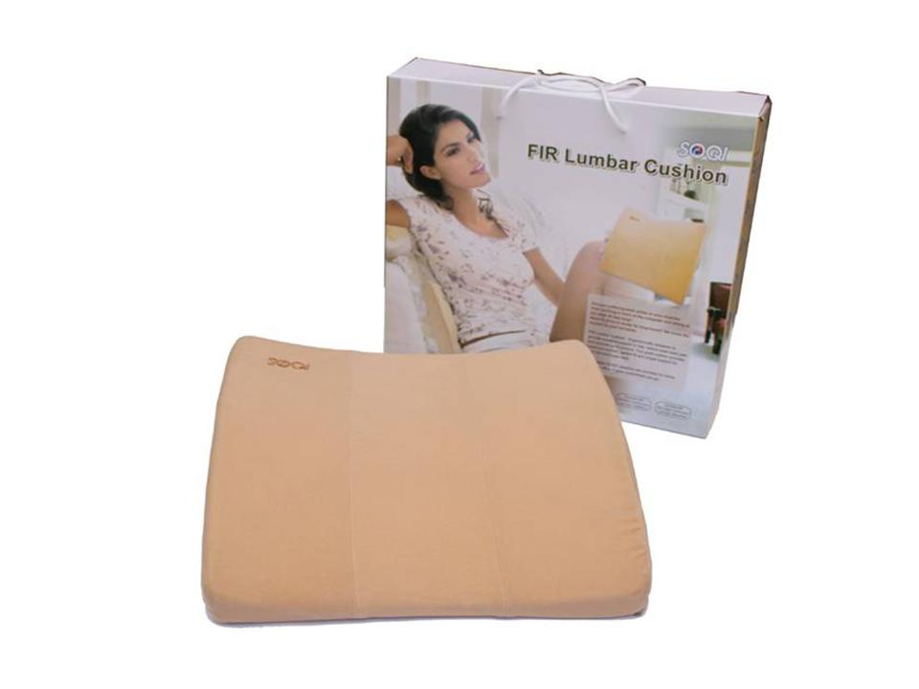  The FIR Lumbar Cushion is an ergonomically designed lumbar support pillow made with high resilient polyurethane material.  Provides the benefits of Far Infrared Rays with heat and vibrating massage.  We have this item in stock. Fits the lumbar well. May be used in a car if you have the right power convertor/generator.  ALL of our products starting with { HTE- } may be purchased with your credit or debit card without the credit card surcharge on our order form.  No Out of Stock Fee with This Item  Order won’t go through if credit card owner and delivery address don’t match.  This is not medical advice & shouldn’t be taken as such. Joni Lund  This machine may or may not do so, not evaluated by the FDA for such. | Item Code: HTE-P0036M01  FIR Lumbar Cushion  USD $ 109.00  BVP 8

