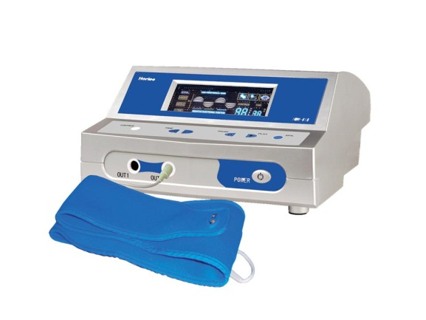110 Volt  E-Power was designed to provide Negative Potential Energy (Energy for Rest) with High Frequency Energy (more ATP). | Item Code: HTE-P0024M01 Mix & Match  E-POWER (Mix & Match)  USD $ 529.00  BVP 42  Extra Promotion Point(s) 12  Special Bundle  HTE-P0025M01  $ 119.00  BVP 7
Negative Potential Energy increases the permeability of cell membranes & enhances the composition of ATP. ATP is adenosine triphosphate-energy carrying molecules found in the cells of living things. ATP transports chemical energy within cells for metabolism.
It is the energy source your body needs not only to survive, but to thrive! E-Power is the source to bring that to you.
Most people don’t have even as much negative energy potential in their cell structure as they should because of aging, disease, poor diet or injury. Because of these factors their cells have to much or more positive energy contained within. When this happens the flow in and out of the body’s cells of fluids, mineral, vitamins, protein, & enzymes is decreased or blocked.
When this happens you age, if the cells are too positive you may contract serious diseases.
SO…. E-Power your way back to health. Balance your Ions. {And you thought chemistry didn’t apply to your life.}
Instructions: 1 or 2 daily sessions for 30 to 60 minutes.
The Main Benefits of E – Power Product Advantages
- Increases ATP 1. Portable and Convenient
- Activates Cells 2. Easy to Handle
- Increases blood Circulation 3. No Known Negative Side Effects
- Detoxifies Your Body 4. Internationally Patented Design
- Normalizes Metabolism 5. Noticable Results
- Adjusts Nervous System 6. Two Ports: 2 people can use at once.
- Boost Immune System
- Improves Physique Joni Lund,
- Enhances Beauty 1295 1st ST S, Carrington, ND 58421
- Improves Skin Phone: (701) 652-1986
- Weight Loss
ALL of our products starting with { HTE- } may be purchased with your credit or debit card without the credit card surcharge on our over form.
No Out of Stock Fee with This Item
Order won’t go through if credit card owner and delivery address don’t match.

This is not medical advice & shouldn’t be taken as such. Joni Lund
This machine may or may not do so, not evaluated by the FDA for such.

