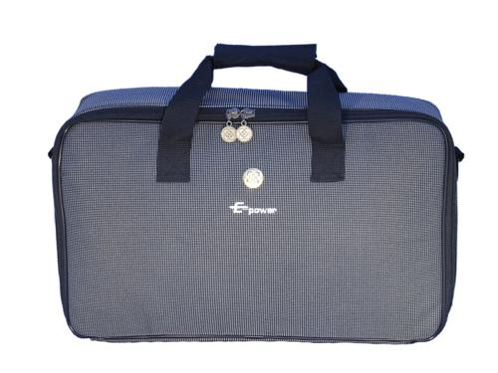 | Item Code: HTE-ASE018012  E-Power Carrying Bag  USD $ 24.99  BVP 1

Protect your valuable E POWER while transporting it with this easy to use case.

