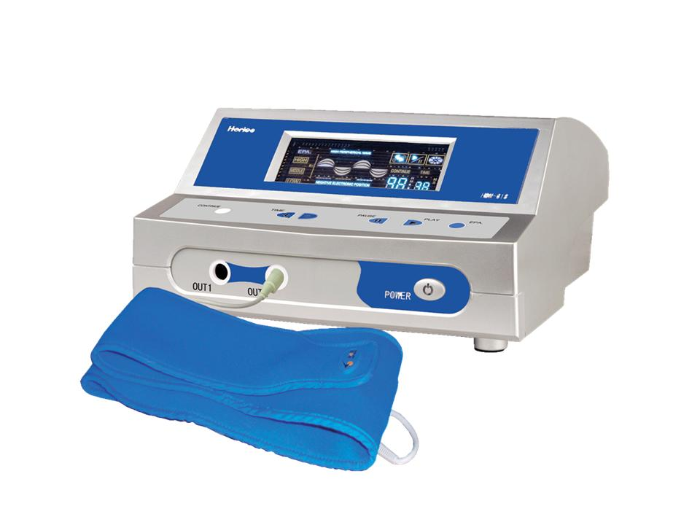 | Item Code: HTE-SE018A4  E-Power 220V  USD $ 649.00  BVP 56

This is not medical advice & shouldn’t be taken as such. Joni Lund
This machine may or may not do so, not evaluated by the FDA for such.

