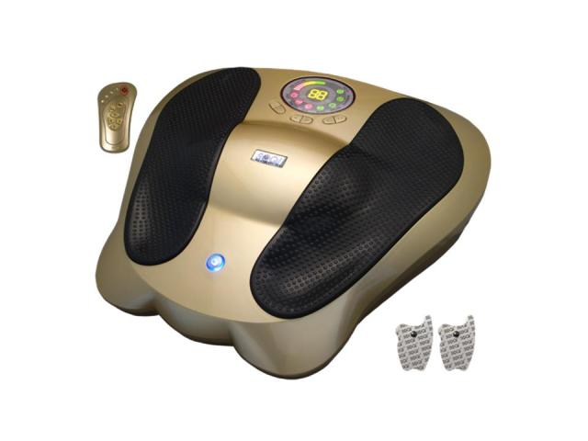 | Item Code: HTE-SR002A2  Advanced Electro Reflex Energizer  USD $ 450.00  BVP 40

ERE stands for Electro Reflex Energizer (Class 1 medical device)
Reflexology is the art of reprogramming atoms cells, & electrons of the body to their original state through the triggering of signal points on the hands or feet. This science deals with the principle that the reflex areas in the hands and feet correspond to all glands, organs, and various other parts of the body.
Reflexology includes but is not limited to relieving stress, tension; improving blood supply, promoting the unblocking of nerve impulses, and helping nature achieve homeostasis.
The Advanced Reflex Energizer is and instrument that helps reconnect broken or damaged electrical pathways within the body by stimulating them with a correct wave form, current, & frequency.
When there is pain in the body there is electrical resistance, meaning the signals between the cells are repressed. Consistent use of the ERE can help restore the flow of electrical currents through the painful area so that the electrical pathways remain turned on and healing can be promoted.
Benefits USE
Foot & body massage by impulses 1 or 2 daily sessions for 5 – 30 minutes
Revitalizes energy
May cleanse body of toxins
May adjust Autonomic Nervous System Joni Lund
May improve local blood circulation 1295 1st ST S
May relieve stressful aches and pains Carrington, ND 58421
May ease tension and reduce fatigue Phone: (701) 652-1986
May assist in weight loss
You are Able to use 3 sets of electro-pads and foot massager at the same time.
DO NOT use this Device if you have any
Electronic medical instruments such as implanted heart beat regulators, artificial hearts, or lungs, or
implanted pace makers.
Persons whom are pregnant, nursing a baby, have a medical condition or are taking any prescription drugs
should consult with their doctors before using.
--------------------------------------------------------------------------------------------------------------------------------------------------------------------
Personally I use it to Kill yeast, molds, mildew, fungus, and parasitic larvae in my body. I do this by free choice & not by any recommendation other then, other people’s success stories. This is not medical advice or should be taken as such. Joni Lund
This machine may or may not do so, not evaluated by the FDA for such.

ALL of our products starting with { HTE- } may be purchased with your credit or debit card without the credit card surcharge on our over form.
No Out of Stock Fee with This Item
Order won’t go through if credit card owner and delivery address don’t match.

This is not medical advice & shouldn’t be taken as such. Joni Lund
This machine may or may not do so, not evaluated by the FDA for such.

