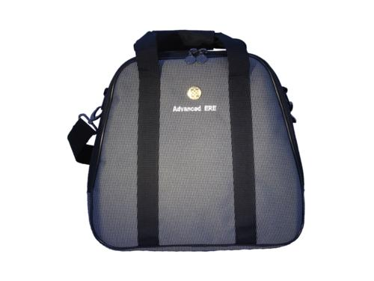 | Item Code: ASE002002  Advanced ERE Carrying Bag  USD $ 24.99  BVP 1

Protect your irreplaceable ERE with this convenient traveling case.

