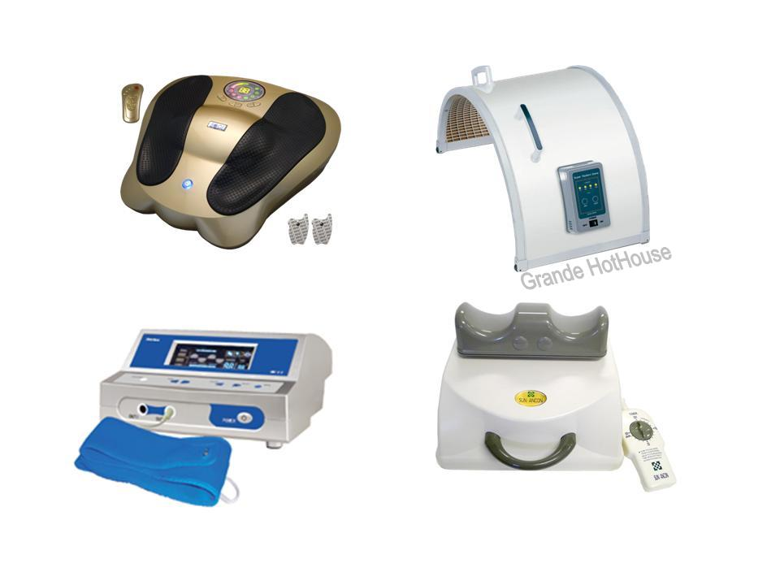 | Item Code: HTE-P0020N01 GRANDE HOT HOUSE  Deluxe Combo II  Package Content  - CHI MACHINE (SDM-888) x 1  - GRANDE HOTHOUSE x 1  - ADVANCED ERE x 1  - E-POWER x 1  Free Give Away  - BLENDING BODY AND SPIRIT (MUSIC CD) x 1  USD $ 2,049.00  BVP 150  Extra Promotion Point(s) 81
FIR Benefits you may experience:
Disclaimer - (results vary with individual, no guarantee of healing or a complete healing).

- Excellent treatment for chronic diseases, especially Cancer- Prostate, Ovarian, Breast, Colon.
- Excellent for alleviation of rheumatism, arthritis, gout, and reducing the density of uric acid.
- Excellent for clearing breathing problems such as asthma, sinusitis, allergies, and bronchitis.
- Very good for relieving paralysis, sciatica, insomnia, neuralgia, abnormal nerve functions, high blood
pressure and chilblains.
- Excellent for reducing swelling, inflammation and associated pain.
- Excellent for serious detoxification.
- Stimulates blood circulation –Very effective for chronic nephritis patients, reducing blood pressure and
improving urination. Effectively improves and can eliminate piles and hemorrhoids.
- Promotes the killing of many pathogenic (disease Causing) bacteria, viruses, fungi, and parasites.
- Far Infrared is excellent for the skin – acne, wrinkles, rashes, burns, scars. Far Infrared regenerates
tissue growth.
- Skin problems such a scars, burns, acne, rashes and wrinkles fade and heal via the far infrared therapy
which stimulates tissue regeneration. Some people have experienced the fading of age spots.

This is not medical advice & shouldn’t be taken as such. Joni Lund
This machine may or may not do so, not evaluated by the FDA for such.

