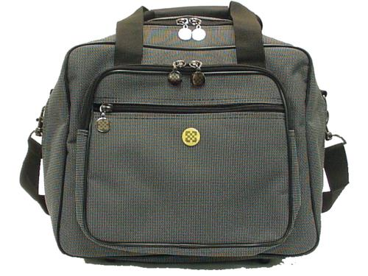 | Item Code: HTE-ASS001001  Chi Machine Carrying Bag  USD $ 29.99  BVP 1

This case protects your health equipment while providing a easy way to transport your Chi machine.

