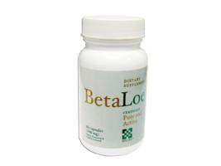 | Item Code: HTE-NB001  BetaLoe  USD $ 29.99  BVP 2

